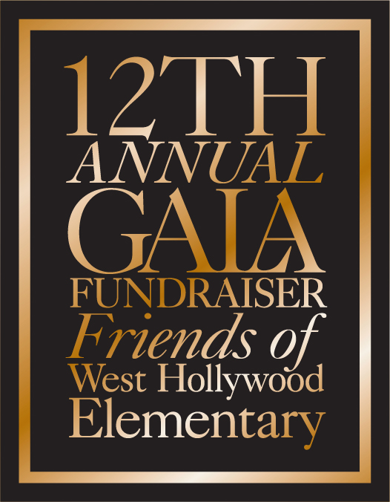

January 2019

Dear Community Partner,

The Friends of West Hollywood Elementary (FOWHE), a 501c(3) charitable parent organization of West Hollywood Elementary (a public school within the Los Angeles Unified School District), will proudly celebrate our eleventh anniversary at our 12th Annual Gala and Silent Auction on March 23rd, 2019 at

Even though LAUSD provides many of the critical elements to make West Hollywood Elementary one of the best schools in California, our parent community believes more is needed. Our organization is 100% run by volunteers so every dollar we raise is invested in the education of our ***own*** children. FOWHE works hard to ensure that WHE has the revenue needed to continually provide extra programs that enhance our children’s education. These “extras” include physical education, music, art, innovation and technology, dance, field trips, teachers’ aides, playground supervision, and an instructional coordinator. Thus, each year, FOWHE strives to raise **$550,000** to fund these critical initiatives.

One thing that sets us apart from other public elementary schools is our extraordinary relationship with our community and, more importantly, the West Hollywood business community. **We hope that you will help us honor our 11th anniversary by helping us to exceed our fundraising goal and lock in the best education for our community’s children.**  Your donation will be seen by over **400** grateful and loyal **families** in the West Hollywood Elementary School circle.

Be part of our 12th anniversary event by donating an item to our silent auction. Your participation will be noticed and remembered by our families.

Please return the completed donation form, along with the item you are donating to the parent who has solicited you by March 1st.

If you wish to mail the item and donation form, kindly mail them in the same envelope or package to FOWHE GALA at 970 N. Hammond St., West Hollywood, CA 90069.

You may choose to complete the donation form online at https://fowhe.ejoinme.org/donate2018 If you

have any questions please email Forest Zuckerman at *forestzukerman@gmail.com.*

**Thank you for stepping up for our kids and improving the future of our community!**

Sincerely,

**The Friends of West Hollywood Elementary Gala Auction Committee**